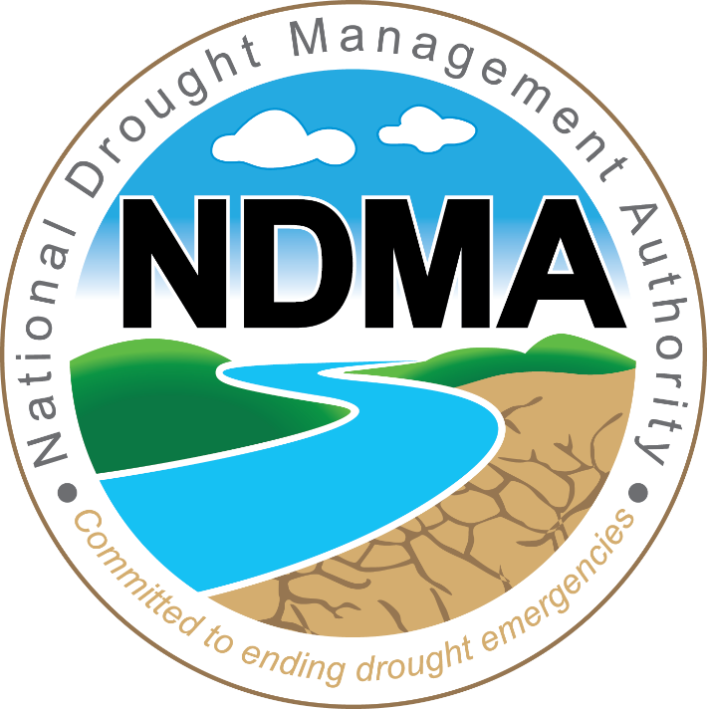

NATIONAL DROUGHT MANAGEMENT AUTHORITY

REGISTRATION OF SUPPLIERS DOCUMENT FOR THE YEAR 2026/2027 AND 2027/2028

INVITATION DATE | 23rd June, 2026
SUBMISSION DATE | 15th July, 2026 at 10:30 am Local Time

INVITATION TO TENDER
The National Drought Management Authority Invites Tenders from Interested and Eligible Contractors and Suppliers for Registrations for Supply and Delivery of Goods, Works and Provision of Services to for the financial years 2026-2027, 2027-2028 as per the listed categories below;
PART I: LIST OF REGISTRATION CATEGORIES

CATEGORY: | ITEM DESCRIPTION (REGISTRATION OF SUPPLIERS) | TARGET GROUP
NDMA/ROS/01/2026-2028 | Supply of General Office Stationery | Youth, women & PWDs
NDMA/ROS/02/2026-2028 | Supply of Assorted Office Furniture and Fittings | Youth, women & PWDs
NDMA/ROS/03/2026-2028 | Supply of Computers, Laptops, Scanners and Tablets | Youth, Women & PWDs
NDMA/ROS/04/2026-2028 | Supply of External Hard disks, Flash drives, USB Cables and other accessories | Youth, women & PWDs
NDMA/ROS/05/2026-2028 | Supply of ICT Consumables (Toners and Cartridges) | Youth, women & PWDs
NDMA/ROS/06/2026-2028 | Provision of ICT Software and support services | Open
NDMA/ROS/07/2026-2028 | Supply of Motor Vehicle Tyres, Tubes and Batteries | Youth, Women & PWDs
NDMA/ROS/08/2026-2028 | Supply of Staff Uniforms | Youth, Women & PWDs
NDMA/ROS/09/2026-2028 | Supply of Servers and other storage devices | Open
NDMA/ROS/10/2026-2028 | Supply of Pasture Seeds | Youth, Women & PWDs
NDMA/ROS/11/2026-2028 | Supply of Marketing and Promotional Materials (Umbrellas, Caps T-Shirts, ) | Youth, Women & PWDs
NDMA/ROS/12/2026-2028 | Supply of Hay | Youth, Women & PWDs
NDMA/ROS/13/2026-2028 | Provision of Air Ticketing Services(IATA Approved firms) | Youth, Women & PWDs
NDMA/ROS/14/2026-2028 | Provision of Motor Vehicle Service and Repairs (CM&TE Approved Garages only) | Open
NDMA/ROS/15/2026-2028 | Supply and Delivery of Animal Feeds | Youth, Women & PWDs
NDMA/ROS/16/2026-2028 | Repair & Maintenance of Computers, desktop UPS’s laptops, Photocopiers and Printers. | Youth, Women & PWDs
NDMA/ROS/17/2026-2028 | Repair & Maintenance of Servers, Server Room UPS’, Air Conditioners and other storage devices | Youth, Women & PWDs Women
NDMA/ROS/18/2026-2028 | Provision of maintenance services of ICT Network Infrastructure (LAN, Wireless Devices etc) | Open
NDMA/ROS/19/2026-2028 | Provision of Maintenance for Information Systems, websites and other Applications | Open
NDMA/ROS/20/2026-2028 | Provision Hosting Services for Websites, Systems and other Applications and installation of SSL certificates. | Open
NDMA/ROS/21/2026-2028 | Repair and Maintenance of Office Furniture & Fittings | Youth, Women and  PWDs
NDMA/ROS/22/2026-2028 | Provision of Office Repairs and Renovations | Youth, Women and  PWDs
NDMA/ROS/23/2026-2028 | Supply and Delivery of Animal Feeds | Youth, Women and  PWDs
NDMA/ROS/24/2026-2028 | Supply and Delivery of General Supplies | Youth, Women and  PWDs
NDMA/ROS/25/2026-2028 | Provision of Motor Vehicle Tracking services and related accessories Garages only) | Open
NDMA/ROS/26/2026-2028 | Provision of Insurance Brokerage Services | Open
NDMA/ROS/27/2026-2028 | Provision of Transportation and Vehicle Hire Services | Open
NDMA/ROS/28/2026-2028 | Provision of Transportation and Vehicle Hire Services | Youth, Women and PWDs
NDMA/ROS/29/2026-2028 | Supply, maintenance and configuration of firewall and firewall licenses. | Youth, Women and PWDs
NDMA/ROS/30/2026-2028 | Supply, maintenance and configuration of virtualisation, backup and replication software. | Youth, Women and PWDs
NDMA/ROS/31/2026-2028 | Provision of Hotels, Conference and Accommodation Services- all the Forty-seven Counties (47) | Open
NDMA/ROS/32/2026-2028 | Advertising and Broadcasting | Open
NDMA/ROS/33/2026-2028 | Provision of Repair and Maintenance of Borehole | Open
NDMA/ROS/34/2026-2028 | Prequalification for Borehole Equipment Installation and Related Materials | Open
NDMA/ROS/35/2026-2028 | Provision of Small Works | Open
NDMA/ROS/36/2026-2028 | Provision of Audio-Visual Production and editing services (Film, documentaries, photography and Videography, public address and related Services) | Open
NDMA/ROS/37/2026-2028 | Provision of Asset Marking/Tracking of Asset System | Open
NDMA/ROS/38/2026-2028 | Supply and delivery of Livestock (cattle, goats, sheep, camel e.t.c) | Open
NDMA/ROS/38/2026-2028 | Supply of fuel and lubricants | Open

REGISTRATION OF DISADVANTAGED GROUPS
REGISTRATION FORM FOR ENTERPRISES OWNED BY WOMEN, YOUTH AND PERSONS WITH DISABILITY TO SUPPLY GOODS, WORKS AND SERVICES TO PROCURING ENTITIES
ACCESS TO GOVERNMENT PROCUREMENT OPPORTUNITIES (AGPO)
The registration of suppliers is aimed at building a profile for each supplier regarding information on general particulars of the company. You are advised that it is a serious offence to give false information on this form.
PART II: DETAILS OF THE APPLICANT
- Name of Applicant……………………………………………………………………………………………………………..

- Physical Address………………………………………………………………………………………………………………..

- Postal Address…………………………………………………………………………………………………………………..

- Postal Code……………………………………………………………………………………………………………………….

- E-mail………………………………………………………………………………………………………………………………

- Mobile Phone No……………………………………………………………………………………………………………..

- Are you applying for youth, women or persons with disabilities?.......................................

- AGPO Number…………………………………………………………………………………………………………………

- EGP Number……………………………………………………………………………………………………………………

- Contact Person………………………………………………………………………………………………………………..

- Bank Account Name………………………………………………………………………………………………………….....

- Branch of the Bank………………………………………………………………………………………………………………..

- Bank Account Number…………………………………………………………………………………………………………..

- VAT Registration Number……………………………………………………………………………………………………..

PART III: OVERVIEW OF THE ENTERPRISE
Type of ownership (please tick one) | [Sole Proprietor] [Limited Company] [Others Specify] [Partnership]
Number of employees | [0-5] [6-25] [26-49] 50-59] [100-250]
Initial Investments (KES)
Total Annual Sales for the previous year (Turnover KES)
Experience in the sector in years

Type of Ownership Details
Part 9 (a) - Sole Proprietor or name of registered business, where applicable
Name in Full |  |  | Age
Identity/Passport No.
Part 9 (b) - Partnership Details
NAME |  | NATIONALITY |  | ID/PASSPORT NO. |  | % SHARES
Part 9 (C) – Registered Companies
State the nominal and issued capital of company
Nominal Kshs……………………………………………………………………Issued Kshs…………………………………………..
Directors' Details
NAME |  | NATIONALITY |  | ID/PASSPORT NO. |  | % SHARES

PART IV: LIST OF ATTACHMENTS
1. Copy of certificate of incorporation/registration;
2. PIN Certificate;
3. VAT Registration Certificate;
4. Valid Tax Compliance/ Exemption Certificate;
5. Original Bank Statement/Bank reference for 6 months from date of applying;
6. Copy of certificate of registration with relevant regulatory bodies (for persons with disabilities registration with National Council for Persons with Disability, NCA Certificates, IATA and KATA Certificates for Air tickets, CM&TE Approved Garages for Motor Vehicle Repairs and IRA for Insurances);
7. Business/Company profile;
8. Copies of Annual Return Forms, filed by Limited Companies, the Business Names for business names (sole trader and partnerships), and a stamped receipt which bears the Accounts Stamp from the Registrar of Companies/Societies; CR12; Partnership Deed;
9. Certificate of Registration in a target group issued by the National Treasury;
10. EGP registration details
11. National IDs/ Passports.

The Registration process shall be conducted ONLINE via Authority’s ERP Portal. Interested and eligible suppliers can access and register on https://tenders.ndma.go.ke/. Where required, all requisite documentation MUST be scanned and uploaded onto the portal.
Hardcopy applications SHALL NOT be accepted.
Existing service providers are required to participate in order to be considered.

Closing Date and Time: 7th July 2026 at 10.30am, East Africa Time

For more information, please reach out on procurement@ndma.go.ke, 0722 200656/734652220

CHIEF EXECUTIVE OFFICER

